N5

MATHEMATICS

PAPER 1
(Non-Calculator) January
Time: 1 hour
Full Name Class

1. You may not use a calculator.
2. Attempt all questions
3. Use blue or black ink. Pencils may be used for graphs and diagrams only.
4. Write your working in the space provided. Additional paper is available if needed. If you use additional paper, write clearly your name and the number of the question you are attempting.
5. Full credit will be given only to solutions which contain appropriate working.
6. State the units for your answer where appropriate.

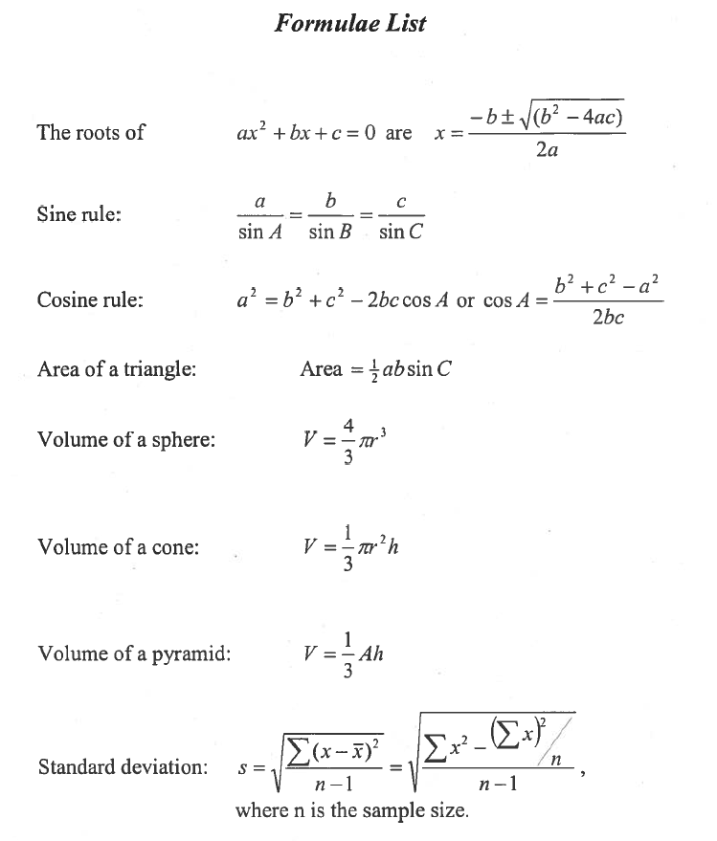
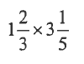
1. Evaluate

(2)

2. Multiply out the brackets and collect like terms

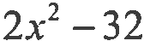
3. Factorise fully
(x- 3)(x2 + 2x- 3)

(3)

(2)

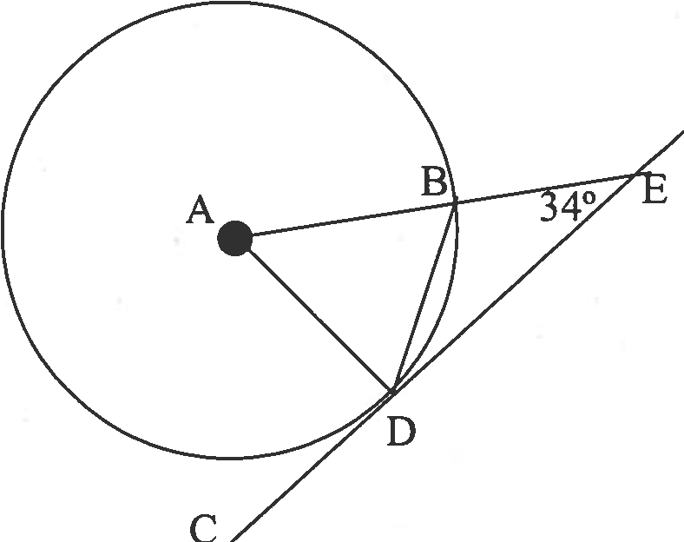
4.
In the diagram opposite with circle centre A:
1. CE is a tangent to the circle at D
2. AE intersects the circle at B
3. Angle DEB = 34°

Calculate the size of the angle ABD

(3)

5. A line has equation 7y - 3x + 18 = 0.
- Find the gradient of the line.

- Determine algebraically the coordinates where the line crosses the x-axis.

(2)

(2)

6. Evaluate $8^{\frac{2}{3}}$

(2)

7. Change the subject of the formula to m.
p = t+3m2

8. Express a 8 x (a3) - 2 in its simplest form
(3)

(2)

9. Dan, Sheila and Daisy are at the cinema with a group of children for a birthday celebration.
a. Dan goes to buy some popcorn and coke.
He buys five large popcorns and two cokes. This costs him £20. Write down an algebraic equation to illustrate this.

b. Sheila now buys three large popcorns and three cokes. This costs her £16·50.
Write down an algebraic equation to illustrate this.

c. Daisy then bought four large popcorns and two cokes.
How much was she charged?

10. Solve the equation 2tan x° – 3 = 0 for 0 ≤ x ≤ 180

(1)

(1)

(4)

(3)

11. The square opposite has diagonals of length 10 centimetres.
Calculate the exact length of the side marked x. Give your answer in its simplest form.
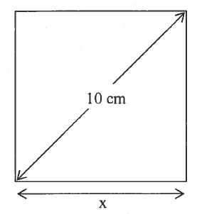

(4)

12. The monthly profit made by a publishing company of a magazine is calculated by the formula
P = 5x(240- x)
where Pis the monthly profit in pounds and xis the selling price in pence of the magazine.
The graph below represents the profit P against the selling price x.

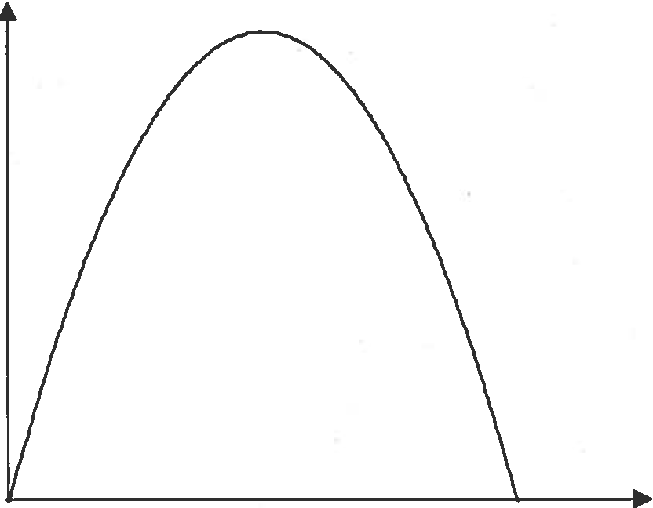
p

X

Find the maximum monthly profit the company can make from the sale of the magazine.

(4)

End of Paper 1.

