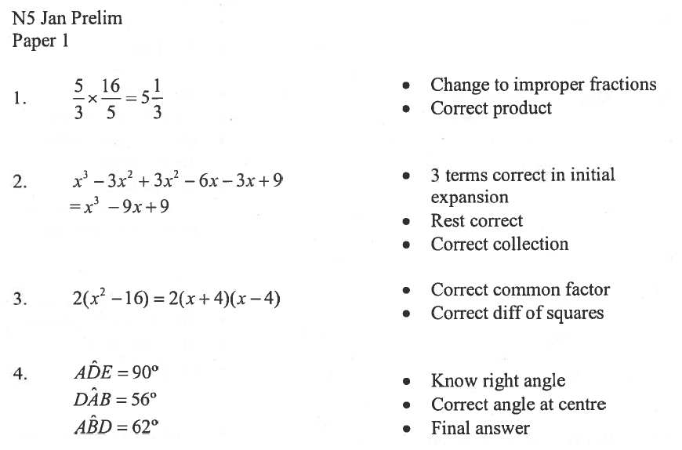
5. a) y = $\frac{3}{7}$x - $\frac{18}{7}$ or y = $\frac{3x-18}{7}$ * Rearrange the formula
m = $\frac{3}{7}$ * Read off gradient

b) y = 0 * Set y = 0
x = 6 * Solve for x

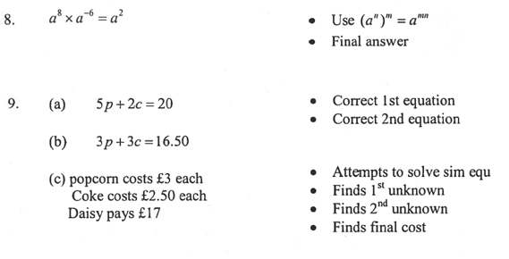
10. tan x = $\frac{3}{2}$ * Rearrange the equation
x = 0.98 * Find x in the 1st quadrant
x = 0.98° * Realise only available one,
answer with units
