NS

MATHEMATICS

PAPER2

January
Time: 1 hour 30 minutes
Full Name Class

1. You may use a calculator.
2. Attempt all questions
3. Use blue or black ink. Pencils may be used for graphs and diagrams only.
4. Write your working in the space provided. Additional
paper is available if needed. If you use additional paper, write clearly your name and the number of the question you are attempting.
5. Full credit will be given only to solutions which contain appropriate working.
6. State the units for your answer where appropriate.
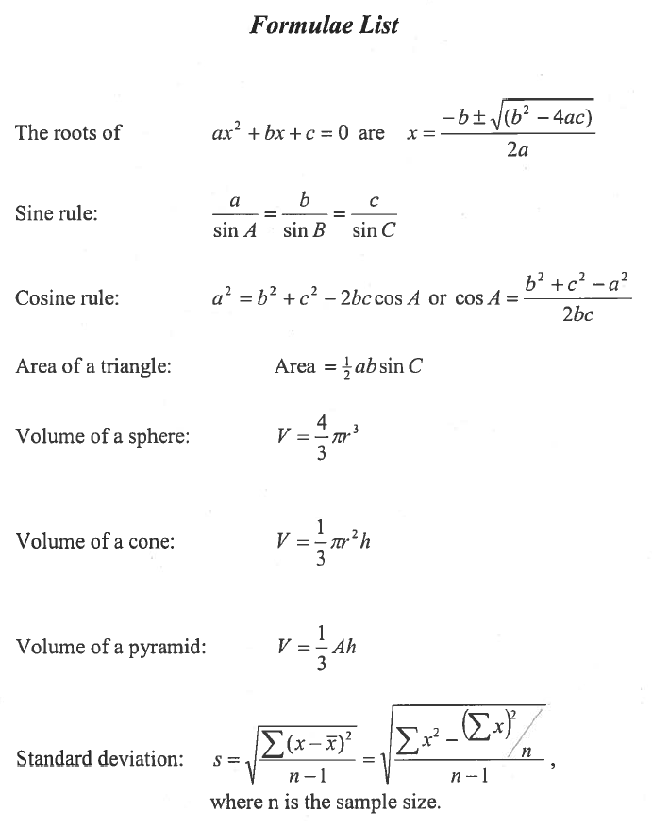

1. Solve the inequality $\frac{3}{5}$ x + 4 < 16
(2)

2. (a) Express x2 +1Ox+ 26 in the form (x +a )2 +b.

(2)

3. Solve the equation x2 + 3x- 5 = _0 .
Give your answers correct to 2 significant figures.

(4)

4. Will's Comittoes are in the shape of a hemisphere sitting on top of a cone.

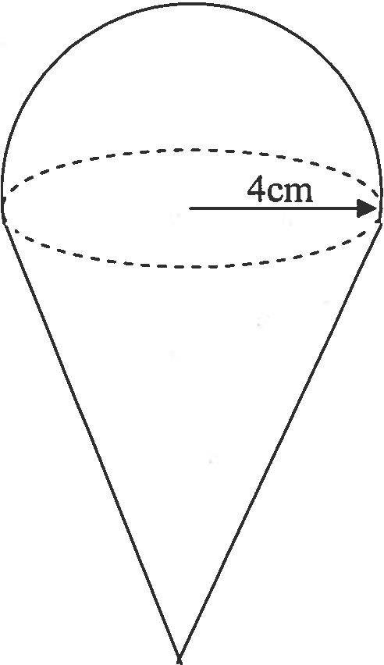The total height of the Comitto is 15 centimetres and the radius of the hemisphere is 4centimetres as shown opposite.

(a) Write down the height of the cone part of the
Comitto.

(b) Calculate the total volume of the Comitto.

15cm

(1)
(4)

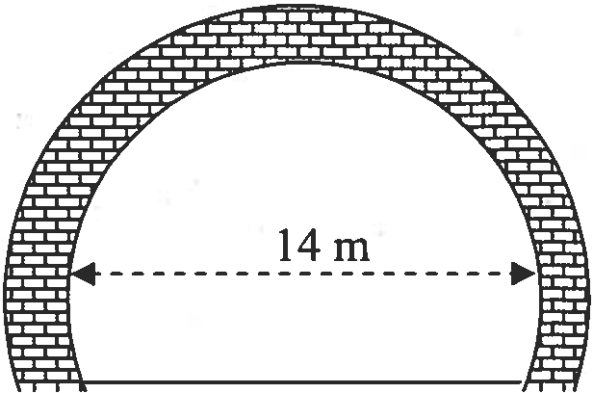5. A tunnel through a hill is formed with a circular cross-section with a diameter of 14 metres.
A horizontal road of width 13 metres is laid in the tunnel as shown below.
Calculate the maximum height in the tunnel.

------------------
13m

(5)

6. The shortest distance from the Sun to Jupiter is 7·41 x 108 kilometres. If light travels at 2·99 x 105 kilometres per second, how long does Sun light take to reach Jupiter?
Give your answer to the neatest minute.

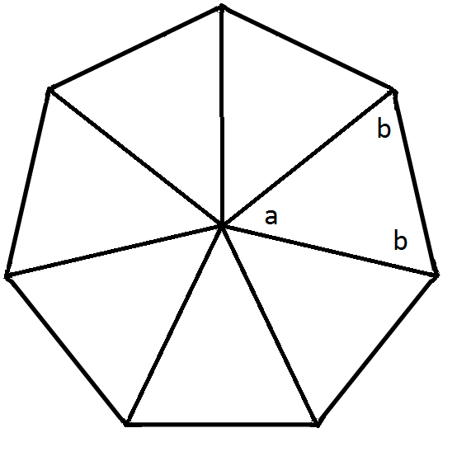
7. The diagram shows a regular heptagon divided into seven congruent triangles.
Find the angle of a and angle b in the triangles.

(3)

(2)

8. The two of bottles of sun screen shown opposite are mathematically similar. The smaller bottle holds
200 millilitres and is 12 centimetres tall. The larger bottle is 15 centimetres tall.
How much does the larger bottle hold?

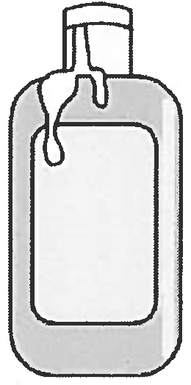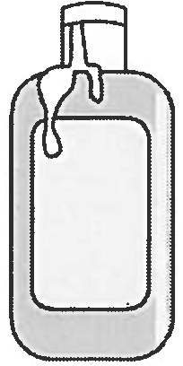

(4)

9. Find the range of values of p such that the equation 2x 2 + 3x + p = 0 has two distinct real roots.
(4)

10. Two variables x and y are connected by the relationship y = ax+ b. Sketch a possible graph of y against x where a < 0 and b > 0 .

y
(2)

X

11. The attendance at a local football match was 1200 people. The entrance fee for adults was £6.50 and children were charged half the adult price. The total amount taken for entry tickets for the game was £6630.
- Write two equations to represent this information.

(2)

- Solve your equations and find the number of adults and the number of children who attended the game.

(4)

12. Sandy wishes to make a witch's hat in the shape of a cone.
He makes it from the sector of a circle.
The slant height of the hat is 40 centimetres.
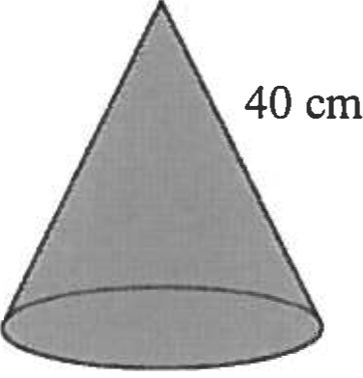The sector arc has to be 60 centimetres long to fit Sandy's head.
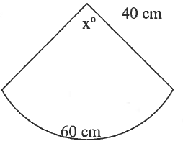

Calculate the angle, X0
,
at the centre

of the sector.

(4)

End of Paper 2

