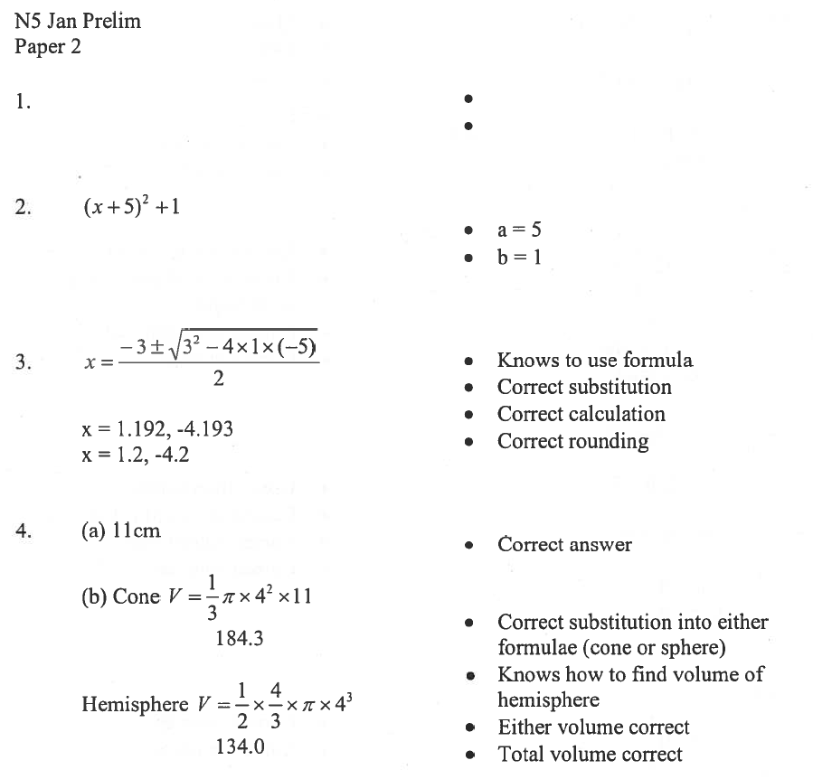
$\frac{3}{5}$x < 12 or 3x + 20 < 80 Begins to solve
x < 20 Finds solution

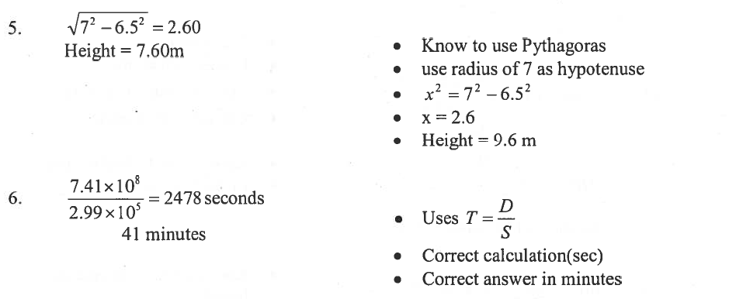

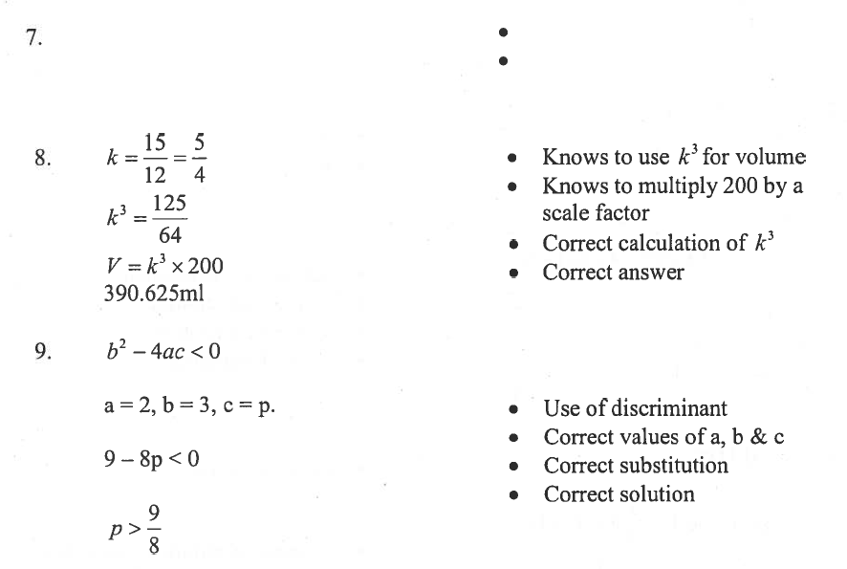
a = 51.4° Found angle a, with units
b = 64.3° Found angle b, with units

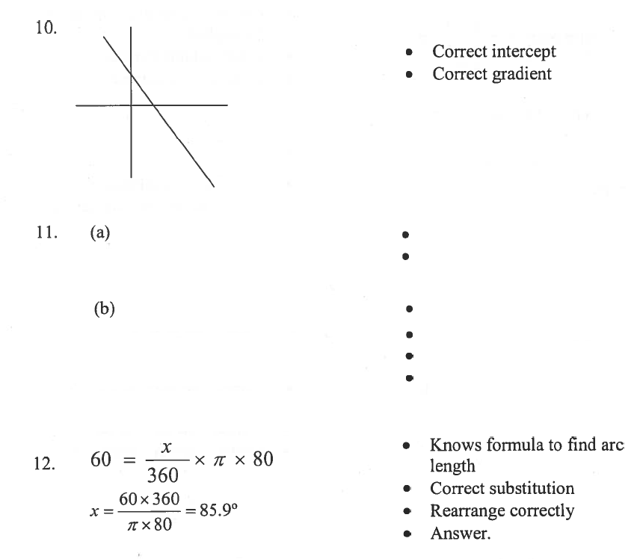

A + C = 1200 Correct 1st equation
6.5A + 3.25C = 6630 Correct 2nd equation

C = 1200 – A Rearranged 1st equation
6.5A + 3.25(1200 – A) = 6630 Substituted into 1st equation
A = 840 Solving for A
B = 360 Solving for B

